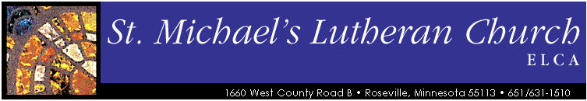
Stock Transfer Form
Please follow these simple steps to notify St. Michael’s of your donation so that it can be properly attributed to your contributions.
- Contact your broker to initiate the transfer of your securities to St. Michael’s Lutheran Church.

- Please complete this form at the time of the gift transfer so we can accurately identify and acknowledge your gift. Send this form to:
St. Michael’s Lutheran Church
1660 W. County Road B
Roseville, MN 55113
Phone: 651-631-1510
Fax: 651-697-1293
Or email the information to office@stmichaelselca.com
Your name and address:
______________________________________________________________________________
______________________________________________________________________________
______________________________________________________________________________
Name of Securities Gifted _________________________________ Number of shares ________
Date of Transfer ________________________________________________________________
Transferring Broker _____________________________________________________________
Company ____________________________________ Phone ____________________________
Electronic Transfer Information
St. Michael’s Broker: Feltl and Company
RBC Capital Markets for the Benefit of St. Michael’s Lutheran Church
DTC #0235
St. Michael’s Account Number: 7R2-06360
Contact: Ben Gilbertson 651-766-1292
Fax: 651-766-1299

